User Manual

Student Registration

(Admission & Academics)

For Colleges



Rajasthan ILD Skills University, Jaipur

This document is to help colleges with the attributes of **Student Registration**:

1. **Browser Installation:** Install & open Web browser Ex: Google chrome, Mozilla Firefox, etc.



1. **User Login:** Log into RISU application using URL & valid login credentials (College, RISU Coordinator and Admin Login).

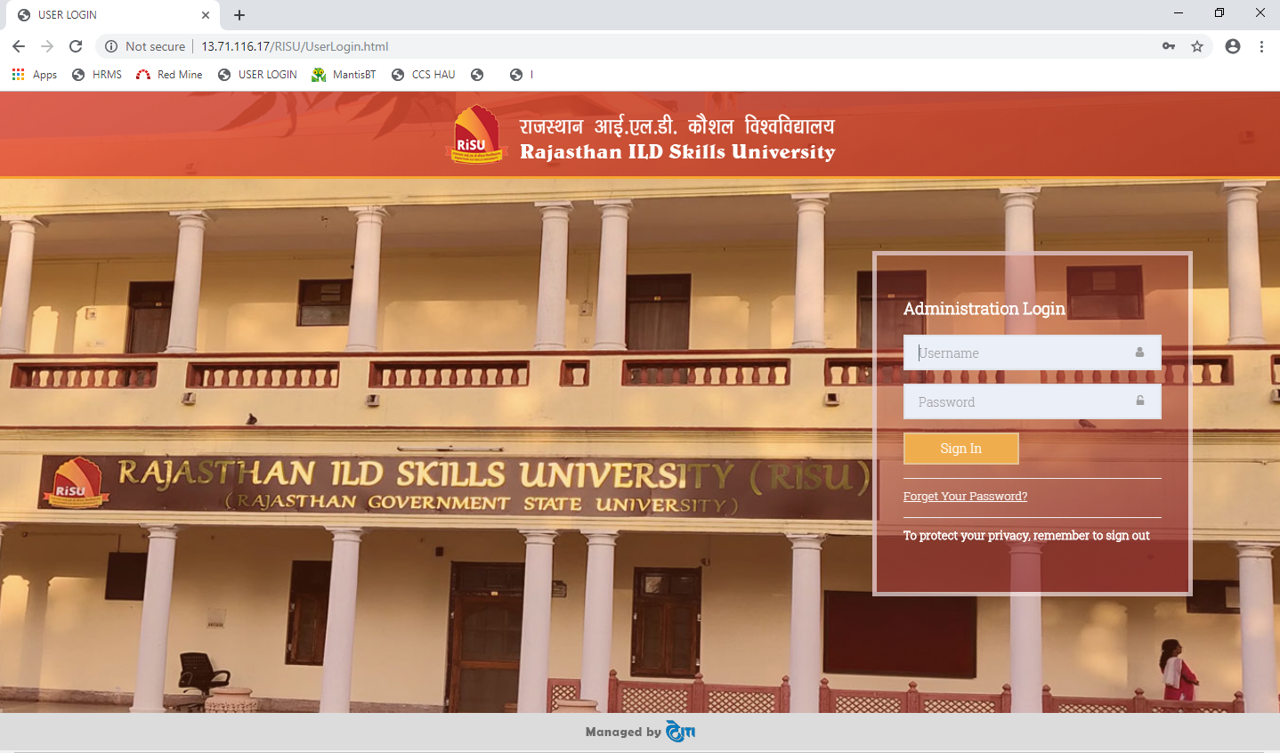

**URL:** <http://risuiums.in/UserLogin.html>

**Username:** User must enter valid username.

**Password:**  User must enter valid password.

1. **Home Page:** On successful login, user is directed to a home page.

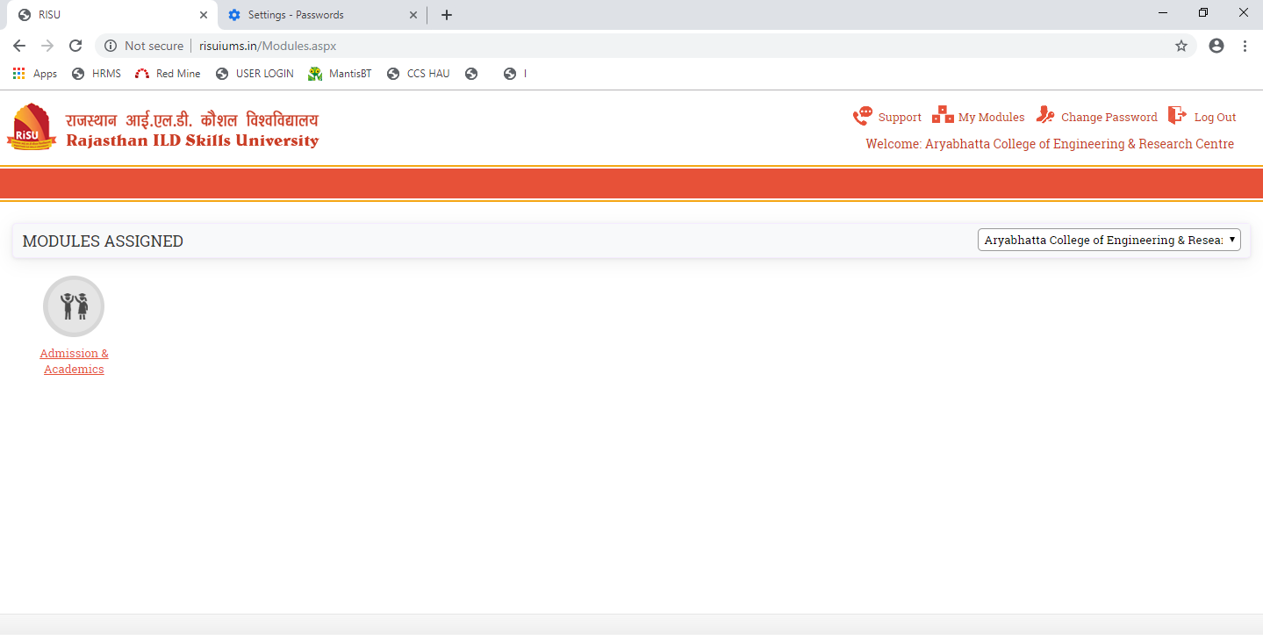

1. **Student Registration:** On College Login, User should click on “**Home Page >> Admission & Academics >> Student Management >> Student Register**”, post clicking, registration form along with already registered students (if any), should be displayed to the user.

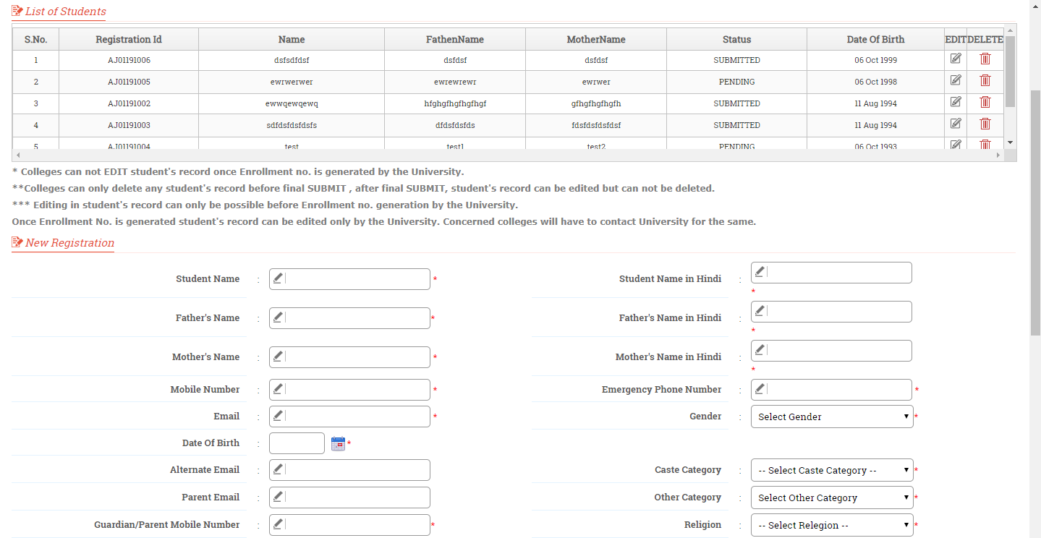

* On First page, user should fill student’s **Basic Information** like Name, Father Name, Mother Name, Email, DOB, etc. **Address Details** like Address line, Nationality, State, Pin code, etc. and **Education** **Details** like Degree type, Board, CGPA, etc.

Post inserting data in all mandatory fields, user should click on “**Save & Continue**” button.

* On Second page, user should upload candidate’s photo and signature, and click on “**Upload**” & then “**Next**” button.
* On third page, user should upload all the mandatory and required candidate’s attachments like 10th Mark sheet, 12th Mark sheet, Migration, etc. , check the **Disclaimer** checkbox (we have checked the eligibility….), and finally click on “**Submit**”.

1. **Intimation to Student:** Once the colleges has finally submitted the student’s registration form, the student will then receive the mail containing his/her filled Enrolment Form. In case if he/she wishes to modify any information, then the same can be done at college end, before Enrolment number generation.

